Calculus-2
Sections: A, C, E

FAST-NUCES
Karachi Campus

Assignment-1
Due on: 27-02-2018

Submission instructions: This assignment should be done individually. Make sure that student name and I.D. are listed on the submission. If you receive help from someone outside your study group, excluding the course staff, you must also acknowledge them on your assignment.

Sequence and Series
Beyond Fibonacci:

As Nerds, you have probably already seen the Fibonacci sequence at some point:
0 1 1 2 3 5 8 13 · · ·
Fibonacci numbers are very much connected to the famous ‘Golden Ratio’ or ‘Divine ratio’ whose value is equal to 1.618…
The larger the Fibonacci numbers, the closer their ratio of last two terms approaches the golden ratio.
Look and say sequence:
How about this one? Here are the first few terms: 1, 11, 21, 1211, 111221,.. . Do you see the pattern yet? It’s not easy; neither of us got it on the first try. How about some more terms, picking up where we left off:
. . . , 312211, 13112221, 1113213211, . . .
Seen enough? Or perhaps we should say, have you heard enough? If you still don’t hear the pattern, try saying each term (after the initial 1) out loud: “one one”, “two one”, “one two, one one”, “one one, one two, two one”,…
1, 11, 21, 1211, 111221, 312211, 13112221, 1113213211, …
Question 1: Determine whether the sequence converges or diverges. If it converges, find the limit.
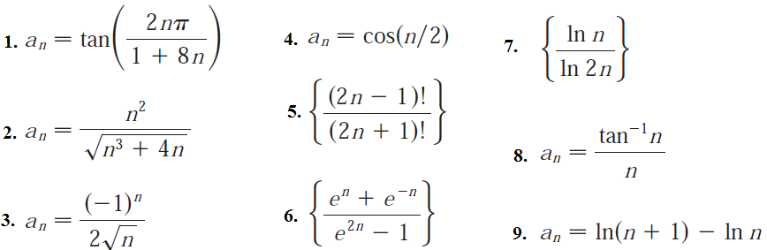
10. 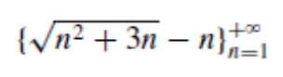 11. 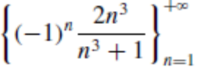 12. 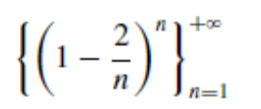

Question 2: A bored student enters the number 0.5 in a calculator display and then repeatedly computes the square of the number in the display. Taking a₀ = 0.5, find a formula for the general term of the sequence {a_{n}} of numbers that appear in the display.
- Try this with a calculator and make a conjecture about the limit of a_{n}.
- Confirm your conjecture by finding the limit of a_{n}.
Question 3: Show that the given sequence is eventually strictly increasing or eventually strictly decreasing.
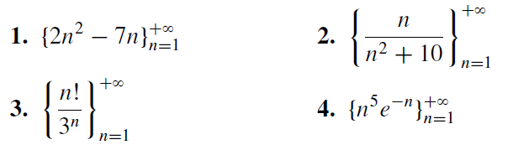
Question 4: Determine whether the series is convergent or divergent by expressing S_{n} as a telescoping sum if applies. If it is convergent, find its sum.
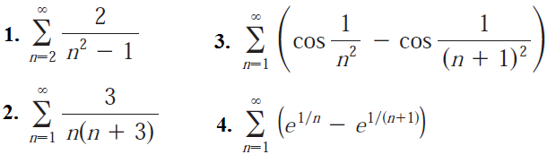
5. 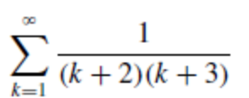 6. 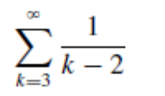
Question 5: Find the values of for which the series converges. Find the sum of the series for those values of x.
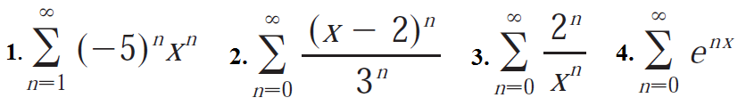
Question 6: A certain ball has the property that each time it falls from a height h onto a hard, level surface, it rebounds to a height rh, where 0 < r < 1. Suppose that the ball is dropped from an initial height of H meters. Assuming that the ball continues to bounce indefinitely, find the total distance that it travels.
Question 7: Peter and Paul take turns tossing a pair of dice. The first to throw a 7 wins. If Peter starts the game, then it can be shown that his chances of winning are given by
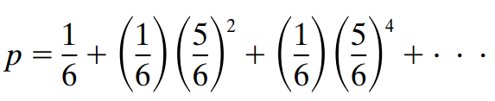
Find the sum.
Question 8: Determine whether the series is convergent or divergent.
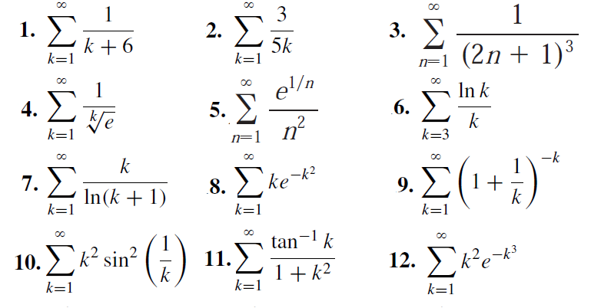
Question 9: Use suitable test to check whether the series is convergent or divergent.
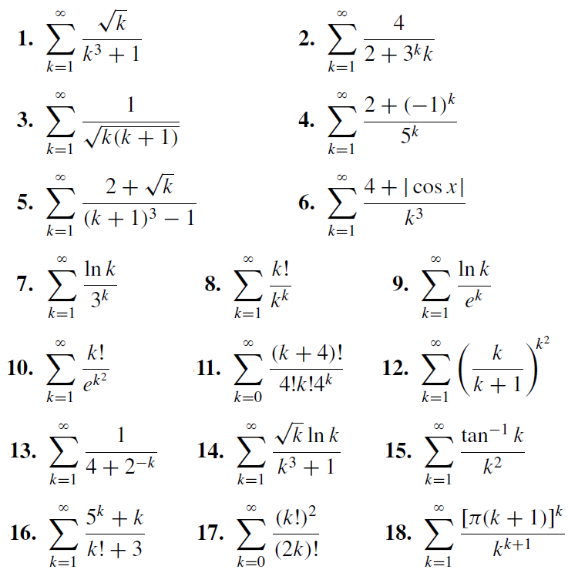
Question 10: Obtain the third Taylor polynomial of 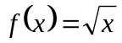 at 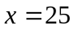 and use it to approximate the value of 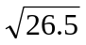.
Question 11: Find the fourth Taylor polynomial of 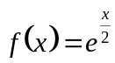 at  and use it to estimate 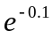.
Question 12: Find the third Taylor polynomial of 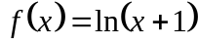 at and use it to estimate the value of
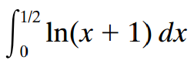
Compare your result with the exact value found using integration by parts.
Parametric and Polar Curves
Parametric graphing is a fun exploration due to the fact that results can be artistically pleasing, and the fact that parametric equations are hardly intuitive, even for the best mathematicians. The equations below involve transcendental, trigonometric, and exponential functions arranged in a non-intuitive manner. However, the result produces a lovely picture of a butterfly!
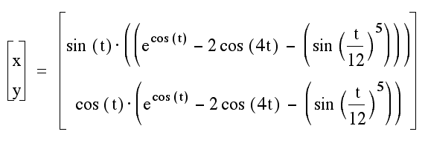
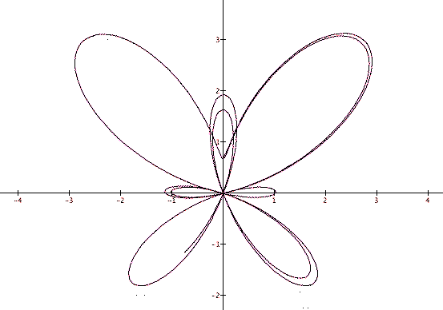

Question 1: Sketch the curve and indicate with an arrow the direction in which the curve is traced as the parameter increases.
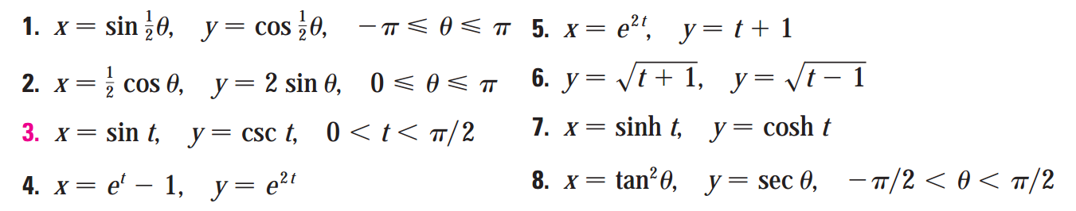
Question 2: Find an equation of the tangent to the curve at the point corresponding to the given value of the parameter
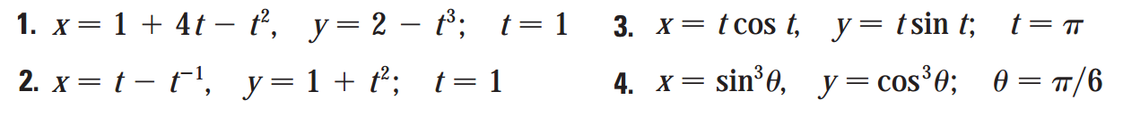
Question 3: A curve C is defined by the parametric equations 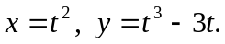
- Find the points on C where the tangent is horizontal or vertical.
- Sketch the curve.
Question 4: Find the length of one arch of the cycloid .
Question 5: Find  and 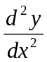. For which values of is the curve concave upward?
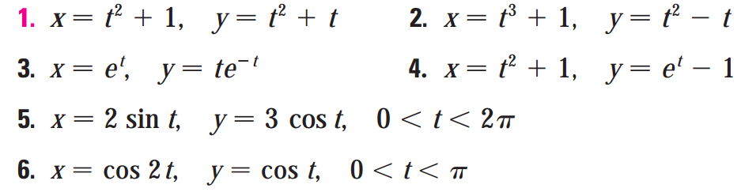
Question 6: Find the exact length of the curve.
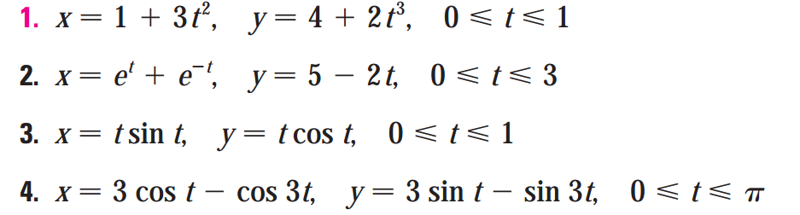

Question 7: Identify the curve by finding a Cartesian equation for the curve.
Question 8: Find a polar equation for the curve represented by the given Cartesian equation.
Question 9: Sketch the curve with the given polar equation by first sketching the graph of as a function of in Cartesian coordinates.
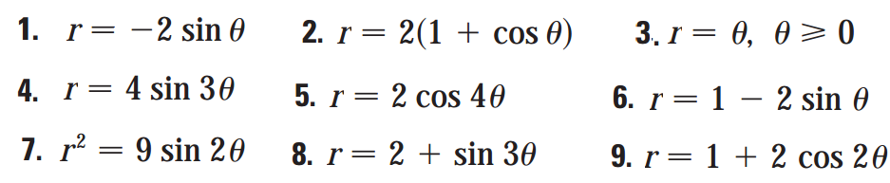
Question 10: Match the polar equations with the graphs labeled I–VI. Give reasons for your choices. (Don’t use a graphing device.)
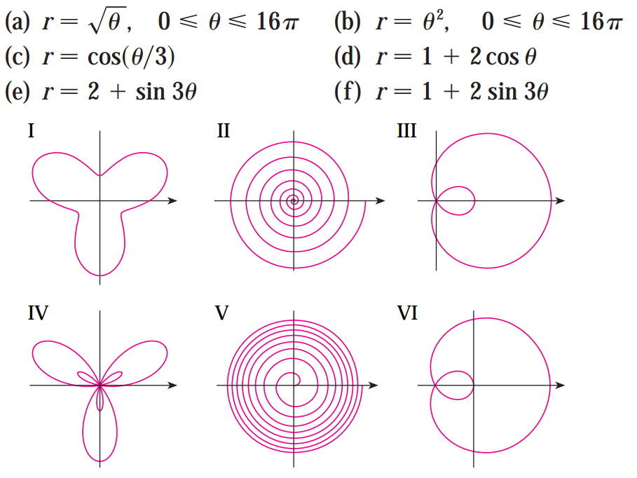
Question 11: Find the slope of the tangent line to the given polar curve at the point specified by the value of .
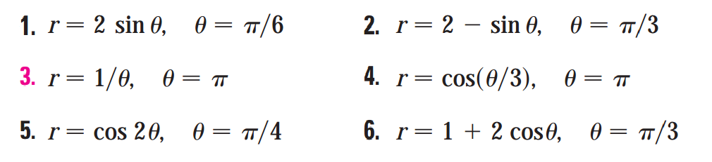
Question 12: Find the points on the given curve where the tangent line is horizontal or vertical.
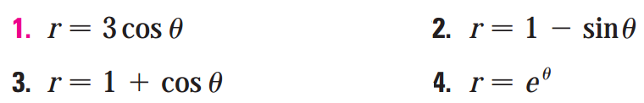
Question 13: Find the exact length of the polar curve.
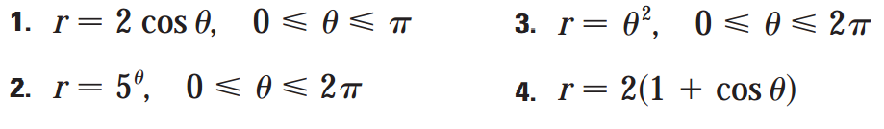
Question 14: Find the exact length of the curve. Use a graph to determine the parameter interval.

Debriefing:
1. How many hours did you spend on this assignment?
2. Would you rate it as easy, moderate, or difficult?
3. How deeply do you feel you understand the material it covers (0% - 100%)?

BEST OF LUCK

